a

PROJECT REPORT ON

Caption Generation using Dynamic hand gesture recognition of sign language

SUBMITTED TO SAVITRIBAI PHULE PUNE UNIVERSITY
FOR PARTIAL FULFILLMENT
OF THE REQUIREMENTS
for the award of the DEGREE OF

BACHELOR OF ENGINEERING
in
Electronics and Telecommunication Engineering

By
Apurva Sonawane B190053271
Shivam Gaikwad B190053075
V Raghavendra Reddy B190053293

GUIDE
Dr. R Sreemathy

Department Of
Electronics and TELECommunication ENGINEERING
PUNE INSTITUTE OF COMPUTER TECHNOLOGY
PUNE – 43

2023 - 24

CERTIFICATE

This is to certify that the Project Report entitled.
Caption Generation using Dynamic hand gesture recognition of sign language

has been successfully completed by
Apurva Sonawane B190053271
Shivam Gaikwad B190053075
V Raghavendra Reddy B190053293

Is a bona fide work carried out by them under the guidance of Dr. R Sreemathy and it is approved for the partial fulfillment of the requirement of the Savitribai Phule Pune University, Pune for the award of the degree of the Bachelor of Engineering (Electronics and Telecommunication Engineering). This project work has not been earlier submitted to any other Institute or University for the award of any degree or diploma.

Dr. R Sreemathy | Dr. M. V. Munot | Prof. Dr. S. T. Gandhe
Guide | HOD, E&TC Dept. | Principal, PICT

Place: Pune
Date :

ACKNOWLEDGEMENT

We want to express our deep gratitude and appreciation to Dr. R. Sreemathy for her invaluable guidance, unwavering support, and insightful supervision throughout the development of our project, titled "Caption Generation using Dynamic Hand Gesture Recognition of Sign Language."

Dr. R. Sreemathy's expertise, patience, and encouragement have played a crucial role in shaping this project. Her mentorship not only provided us with a solid foundation for our research but also inspired us to expand our knowledge and skills. We also want to extend our heartfelt thanks to the entire faculty and staff at PICT for their consistent support and the resources they made available to us during this project.

This project has been a significant learning experience, and we are thankful for the opportunity to work on such an important topic in the field of sign language and gesture recognition. We hope that our research will make a positive contribution to the advancement of technology for the deaf and hard-of-hearing community.

Thanking You,
Apurva Sonawane
Shivam Gaikwad
V Raghavendra Reddy

CONTENTS

 | Abstract |  | i
 | List of Acronyms |  | ii
 | List of Symbols |  | iii
 | List of Figures |  | iv
 | List of Tables |  | v
1 | Introduction |  | 9-19
 | 1.1 | Background | 9
 | 1.2 | Relevance | 10
 | 1.3 | Motivation | 11
 | 1.4 | Aim of the Project | 12
 | 1.5 | Scope and Objectives | 14
 | 1.6 | Technical Approach | 16
2 | Literature Survey |  | 20-27
 | 2.1 | Introduction | 20
 | 2.2 | Computer Vision in Gesture Recognition | 21
 | 2.3 | Gesture Recognition Approaches | 23
 | 2.4 | Bridging the Gap | 26
3 | Methodology |  | 28 - 40
 | 3.1 | Implementation Methodology | 28
 | 3.2 | Data Collection and Preprocessing | 29
 | 3.3 | YOLOv5 Architecture Overview | 31
 | 3.4 | Model Training Process | 34
 | 3.5 | Experimental Setup and Evaluation | 37
 | 3.6 | Evaluation and Optimization | 42
 | 3.7 | Ethical Considerations | 43
4 | Results and Discussions |  | 44-48
 | 4.1 | Results | 44
5 | Conclusions & Future Scope |  | 49-51
 | References |  | 52-53
 | Plagiarism Report

ABSTRACT

Communication barriers persistently challenge the deaf and hard-of-hearing community in contemporary society. Conventional methods of sign language interpretation predominantly rely on human interpreters, leading to restricted accessibility, potential misinterpretations, and communication limitations. To mitigate these challenges, the development of automated systems capable of accurately recognizing dynamic hand gestures in sign language and generating corresponding text captions is imperative.
Our project endeavours to address this communication gap by crafting a robust system for hand gesture recognition and text caption generation. By enhancing the communication experience for individuals who are deaf or hard of hearing, our overarching objective is to facilitate more seamless interaction with the wider community. Through meticulous research and development, we seek to forge a dependable system proficient in accurately identifying hand gestures and generating text captions in sign language. This initiative represents a significant leap forward in confronting the communication hurdles confronted by the deaf and hard-of-hearing community. By attaining exceptional levels of precision in both gesture recognition and caption generation, our system pledges to contribute substantially to augmenting the accessibility and inclusivity of communication for this demographic. In addition to the technical advancements, our project encompasses various socio-economic implications. By empowering individuals with hearing impairments to communicate more effectively, we aspire to promote greater social integration and equality.
Moreover, our project underscores the importance of interdisciplinary collaboration between fields such as computer vision and assistive technology. By synergizing insights and methodologies from these diverse domains, we aim to develop innovative solutions that transcend conventional boundaries and deliver tangible benefits to society. In summary, our project signifies a concerted effort to leverage technological advancements for the betterment of communication accessibility for the deaf and hard-of-hearing community.

Abbreviations and Acronyms
CNN | Convolutional Neural Networks
RNN | Recurrent Neural Networks
LSTM | Long Short-Term Memory
VBT | Vision Based Transformation
ATL | Attention Based Learning
ROI | Region of Interest
ML | Machine Learning
DL | Deep Learning
YOLO | You Only Look Once
ASL | American Sign Language
mAP | Mean Average Precision
ADA | Adaptive gradient algorithm
RMSProp | Root mean square propagation

List of Figures
Fig.1.1 | Hand gesture recognition process | 12.
Fig 1.2 | Workflow of gesture recognition | 14.
Fig 1.3 | System Flow Diagram | 17.
Fig 3.1 | Referenced Dataset | 28.
Fig 3.2 | Augmentation on the training set | 34.
Fig 3.3  Fig 3.4 | AUGMENTATION TECHNIQUE  Convolutional Neural Networks | 36.  40.
Fig 3.5 | Pooling layer | 40.
Fig 3.6 | Fully Connected Layer | 40.
Fig 4.1 | Detection of “Please” | 46.
Fig 4.2 | Detection of “Thank You” | 46.
Fig 4.3 | Detection of “Hello” | 47.
Fig 4.4 | Confusion matrix on validation set. | 47.
Fig 4.5 | Overall results. | 48.

CHAPTER 1

Introduction

  - Background
Throughout history, one persistent challenge has been overcoming the communication barrier between individuals with hearing impairments and the general populace. Sign language serves as a vital mode of communication for the deaf community, yet its complexity can pose challenges for those unfamiliar with its intricacies. Hence, there exists an urgent need for a system capable of swiftly and accurately translating sign language gestures into text, thereby ensuring equitable access to information and communication for all.
The project "Caption Generation through Dynamic Hand Gesture Recognition of Sign Language" represents a significant breakthrough in revolutionizing how sign language is perceived and understood. By developing a system adept at recognizing and translating dynamic hand gestures in real-time, we have the potential to markedly enhance accessibility for individuals with hearing disabilities. This not only empowers individuals in their daily interactions but also fosters inclusivity across various societal domains, spanning education, employment, and social engagement. The importance of the "Caption Generation through Dynamic Hand Gesture Recognition of Sign Language" project cannot be overstated. It addresses a critical need within the deaf and hard-of-hearing community, namely, the ability to communicate effectively and access information in real-time. By providing a means to translate sign language gestures into text instantaneously, our project aims to break down communication barriers and promote inclusivity.
Furthermore, the societal impact of our project extends beyond formal settings to encompass everyday interactions and social engagements. By enabling individuals with hearing disabilities to communicate effortlessly with their peers, friends, and family members, we aim to promote social integration and combat social isolation within the deaf community. The significance of the project lies in its potential to revolutionize communication accessibility for individuals with hearing impairments, thereby enhancing their quality of life, and fostering a more inclusive society.

  - Relevance
The project "Caption Generation using Dynamic Hand Gesture Recognition of Sign Language" holds significant relevance to the field of Electronics and Communication Engineering (ECE) and its related subjects, owing to its multifaceted nature and alignment with critical components of the curriculum.
- Signal and Image Processing: Signal and Image Processing are fundamental to the project, serving as essential tools for analysing and interpreting the intricate hand gestures inherent in sign language. Advanced signal processing techniques, such as Fourier analysis and wavelet transforms, are employed to gain insights into handling complex data signals. Additionally, image processing algorithms enable the extraction of meaningful features from video streams, facilitating the recognition and classification of dynamic hand movements—a vital aspect of sign language interpretation.
- Machine Learning and Artificial Intelligence: The project heavily relies on Machine Learning (ML) and Artificial Intelligence (AI) techniques for developing the gesture recognition system. ML algorithms, including support vector machines and deep neural networks, are utilized to train models capable of accurately recognizing and interpreting a wide range of sign language gestures. Concepts such as transfer learning and reinforcement learning further enhance model performance and adaptability to diverse sign language variations.
- Interdisciplinary Approach: The interdisciplinary nature of the project promotes a holistic understanding of ECE concepts. Drawing upon principles from computer vision, linguistics, and human-computer interaction, the project transcends traditional disciplinary boundaries. Students are encouraged to integrate knowledge from diverse domains to solve real-world problems effectively. This approach fosters a deeper understanding of the interconnectedness of different fields within engineering and equips students with the versatility to tackle complex challenges in their future careers.
- Curriculum Alignment: The project aligns seamlessly with key components of the ECE curriculum, providing us with practical exposure to cutting-edge technologies and methodologies. Through firsthand experience in signal processing, machine learning, and interdisciplinary collaboration, students develop critical skills that are directly applicable to their academic and professional pursuits.
- Promotion of Inclusivity: By developing a system that enables real-time caption generation for sign language gestures, the project contributes to the promotion of inclusivity in society. Students gain insight into the societal impact of technology and the role of engineers in addressing real-world challenges related to accessibility and communication.
In conclusion, the project "Caption Generation using Dynamic Hand Gesture Recognition of Sign Language" exemplifies the interdisciplinary nature of modern engineering endeavours and aligns closely with the core principles of the ECE curriculum. By integrating concepts from signal processing, machine learning, and interdisciplinary collaboration, the project equips students with the skills and knowledge necessary to make meaningful contributions to the advancement of technology and the promotion of inclusivity in society.

  - Motivation
The motivation behind the project "Caption Generation using Dynamic Hand Gesture Recognition of Sign Language" stems from the persistent communication challenges faced by the hearing-impaired community. Despite significant advancements in sign language recognition research, notable gaps and limitations persist, necessitating further exploration and innovation.
Early studies laid a crucial foundation by focusing on basic signs and fingerspelling recognition. However, these efforts primarily addressed isolated gestures and lacked the capacity to interpret the nuanced dynamics of real-time sign language communication. Consequently, there is a clear need for more sophisticated techniques capable of capturing the fluidity and complexity of natural sign language expressions. The integration of computer vision techniques marked a significant step forward, showcasing the potential of feature extraction and pattern recognition algorithms in deciphering hand gestures. Nevertheless, existing methods often struggle with real-world scenarios, where variations in lighting conditions, hand orientation, and background clutter can significantly impact recognition accuracy.

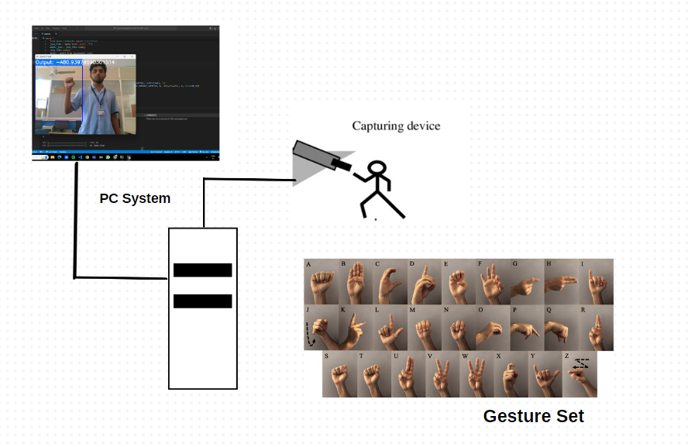

Fig.1.1: Hand gesture recognition process

Recent advancements in deep learning, particularly the emergence of recurrent neural networks and convolutional neural networks, have sparked optimism in the field. These approaches offer improved capabilities in capturing temporal and spatial dependencies within sign language gestures, thus enhancing recognition accuracy and robustness. The dynamic nature of sign language poses unique difficulties, including the need to accurately interpret subtle movements and gestures occurring in rapid succession. Additionally, ensuring real-time performance remains a critical consideration for practical applications, particularly in scenarios where immediate communication is essential. Our project aims to address these challenges by leveraging the latest advancements in machine learning, computer vision, and signal processing. By building upon previous research and integrating novel methodologies, we seek to develop an innovative caption generation system capable of accurately translating dynamic hand gestures into text in real-time.
Through our efforts, we aspire to not only advance the field of dynamic hand gesture recognition but also contribute to creating a more inclusive and accessible environment for individuals with hearing disabilities. This project serves as a catalyst for bridging the communication gap and promoting equal opportunities for participation and engagement in various aspects of society.

  - Aim of the Project
The aim of the project is to pioneer the development of an advanced caption generation system that leverages dynamic hand gesture recognition within sign language. Our core objective is to address the formidable challenge of accurately interpreting the intricate hand movements inherent in sign language and promptly converting them into written text. We aim to surpass current limitations hindering the faithful capture of the subtle nuances present in dynamic sign language gestures, striving for a solution that guarantees precision and agility in transforming gestures into comprehensible text.
Furthermore, our project aims to push the boundaries of accessibility and inclusivity for individuals with hearing impairments by providing them with a dependable and efficient means of communication. By delivering a real-time caption generation system that seamlessly bridges the gap between sign language and written language, we endeavour to empower the deaf and hard-of-hearing community to engage more fully in various facets of life, including education, professional endeavours, and social interactions. This project seeks to tackle the challenge of accurately interpreting dynamic hand gestures in sign language and converting them into written text in real-time. This addresses the longstanding communication barrier faced by the deaf and hard-of-hearing community. The system aims to surpass current limitations and ensure accurate and prompt conversion of gestures into comprehensible text. This involves developing sophisticated algorithms capable of capturing the nuances of sign language expressions in diverse real-world scenarios. The significance of the project lies in its contribution to creating a more equitable society where communication barriers are significantly diminished. By enhancing accessibility and inclusivity for individuals with hearing impairments, the project aligns with broader societal goals of promoting diversity, equity, and inclusion. Moreover, the project aims to empower individuals with hearing disabilities to participate actively and meaningfully in various aspects of life, including education, employment, and social interactions, thus fostering a more inclusive and supportive community.
In terms of innovation and technological advancement, the project represents a pioneering effort in the field of dynamic hand gesture recognition and caption generation. By leveraging state-of-the-art technologies such as deep learning and computer vision, we aim to develop a cutting-edge solution that sets new benchmarks for accuracy, efficiency, and usability in sign language interpretation systems.

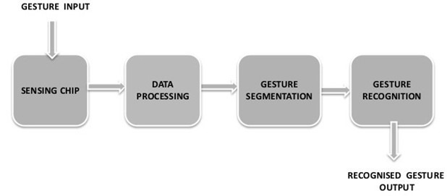
Fig 1.2: workflow of gesture recognition

  - Scope and Objectives
This report covers a thorough analysis and implementation of a real-time system that generates captions by recognizing dynamic hand gestures in sign language. It involves using advanced computer vision techniques, machine learning, and natural language processing to accurately interpret and translate complex hand movements into written captions. We also explore various deep learning approaches, data enhancement methods, and real-time processing frameworks to make sure the system is strong, accurate, and responsive. The report also discusses how this system can enhance communication and inclusivity for people with hearing impairments in different settings, like schools, workplaces, and public places.
Here are the project's objectives in simpler terms:
- Understanding Sign Language Gestures: To successfully recognize and translate sign language gestures, it is essential to first gain a deep understanding of the intricacies and nuances inherent in these gestures. This involves studying various sign language alphabets, common gestures, and their meanings, as well as the challenges associated with interpreting them in real-time.
- Implementing Computer Vision Techniques: Computer vision techniques play a crucial role in capturing and analysing hand movements in sign language. This objective involves implementing advanced algorithms for feature extraction, gesture tracking, and motion analysis to accurately detect and interpret dynamic hand gestures captured in video streams.
- Integrating Machine Learning Algorithms: Machine learning algorithms are employed to enhance the system's ability to recognize and interpret sign language gestures with precision and context awareness. This objective entails exploring a range of machine learning models, including deep neural networks, recurrent neural networks, and convolutional neural networks, to effectively capture the temporal and spatial dependencies inherent in sign language gestures.
- Designing Real-Time Caption Generation System: The ultimate goal of the project is to design and develop a real-time caption generation system capable of seamlessly converting recognized hand gestures into readable text. This involves creating an intuitive user interface and integrating the caption generation functionality with the underlying computer vision and machine learning components to ensure smooth and efficient operation.
- Evaluating System Performance: Rigorous testing and validation are essential to assess the performance and accuracy of the developed system. This objective involves conducting extensive testing under various conditions, including different lighting environments, hand orientations, and background clutter, to evaluate the system's robustness and reliability in real-world scenarios.
- Demonstrating Practical Applications: The practical applications of the developed system extend beyond individual use cases to broader societal impacts. By facilitating effective communication for individuals with hearing impairments, promoting inclusivity, and fostering a more accessible environment, the project aims to make a tangible difference in the lives of people with disabilities across various domains, including education, employment, and social interactions.
By achieving these objectives, the project aims to solve the problem of generating captions efficiently from dynamic hand gestures in sign language. This will contribute to making communication and accessibility better for the hearing-impaired community.

  - Technical Approach
Our technical approach is designed to tackle the complexities of dynamic hand gesture recognition and caption generation in sign language, employing a combination of cutting-edge techniques in machine learning, YOLOv5 and computer vision. Here's a detailed breakdown of each aspect of our approach:
1. Dataset Creation:
- Utilize a professional camera to capture high-quality images of sign language gestures.
- Implement a systematic approach to cover a wide range of gestures, ensuring diversity and representation.
- Apply consistent lighting conditions and background settings for uniformity across the dataset.
- Aim to accumulate a substantial dataset size, considering the complexities and nuances of sign language gestures.
2. Manual Classification:
- Undertake a meticulous manual classification process to categorize each image into distinct sign language gestures.
- Assign appropriate labels to each image, ensuring accuracy and consistency in classification.
- Iterate through the dataset to validate the correctness of labels and make necessary adjustments.
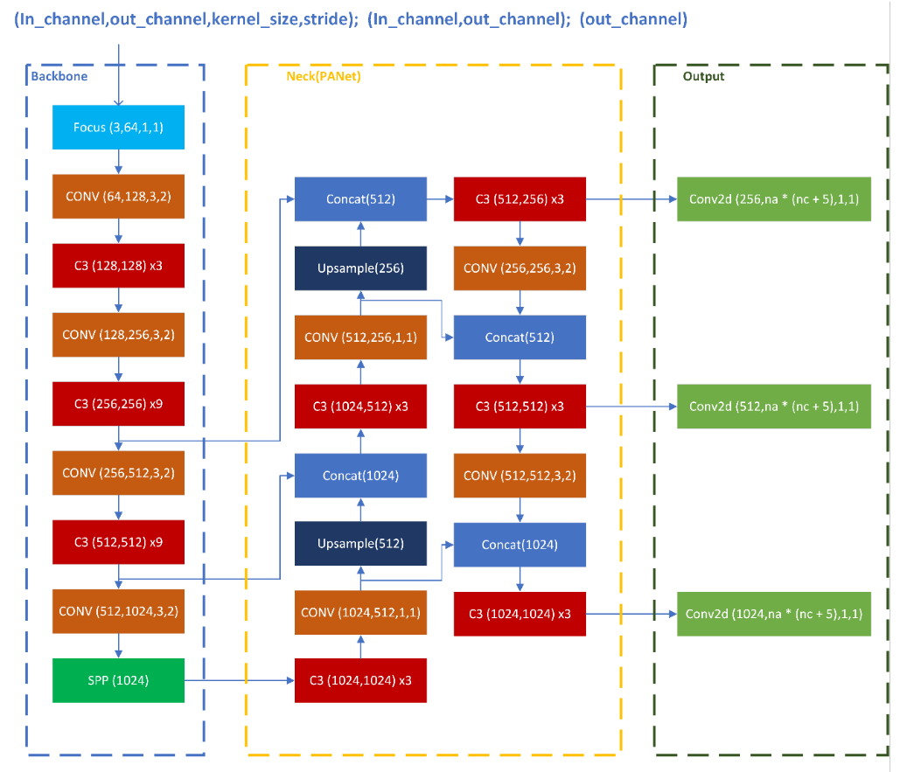
Fig 1.3: System Flow diagram
3. Dataset Splitting:
- Divide the labelled dataset into three subsets: training, validation, and testing, maintaining specific ratios.
- Allocate 70% of the dataset for training, 15% for validation, and 15% for testing to ensure an adequate balance between model training and evaluation.
- Randomly shuffle the dataset to prevent any biases in each subset.
4. Data Augmentation:
- Apply various augmentation techniques to augment the training dataset, enhancing its size and diversity.
- Techniques such as contrast adjustment, rotation, mirroring, and brightness adjustment can be employed to introduce variations in the dataset.
- Customize augmentation parameters based on the characteristics of sign language gestures to ensure realism and relevance.
5. YOLOv5 Object Detection Model:
- Implement YOLOv5, a state-of-the-art object detection model, for recognizing hand gestures in sign language.
- Fine-tune the chosen YOLOv5 variant using the pre-processed dataset to specialize in detecting sign language gestures.
- Optimize model hyperparameters and architecture to achieve the desired balance between accuracy and computational efficiency.
6. Training and Evaluation:
- Train the YOLOv5 model using the augmented dataset, leveraging GPU acceleration for efficient training.
- Monitor training progress using metrics such as loss curves, accuracy, and validation performance.
- Regularly validate the model's performance on the validation dataset to prevent overfitting and ensure generalization.
- Evaluate the trained model on the test dataset to assess its effectiveness in recognizing sign language gestures accurately.
7. Caption Generation:
- Integrate the trained YOLOv5 model with computer vision algorithms to detect hand gestures in real-time.
- Develop a mechanism to interpret detected gestures and generate corresponding captions or translations.
- Implement language processing techniques to refine and contextualize the generated captions for improved readability and coherence.
- Validate the caption generation system through user testing and feedback, iterating on improvements based on user experience.
8. Optimization and Deployment:
- Optimize the trained model and caption generation pipeline for efficiency and real-time performance.
- Package the system into a deployable format suitable for integration with various platforms or applications.
- Conduct thorough testing and validation in real-world scenarios to ensure robustness and reliability.
- Deploy the finalized system for practical use, potentially integrating it with assistive technologies or communication devices for the hearing impaired.
By implementing this comprehensive technical approach, our project aims to develop a versatile and reliable system that accurately recognizes dynamic hand gestures in sign language and generates coherent textual captions in real-time. This solution has the potential to significantly enhance communication and inclusivity for individuals with hearing disabilities, empowering them to participate more fully in various aspects of life.

CHAPTER 2

Literature Survey

2.1 Introduction
Understanding the current landscape of research in the intersection of computer vision, natural language processing, and assistive technology is crucial for contextualizing our innovative approach. Several studies have explored the application of computer vision and gesture recognition for enhancing communication accessibility, particularly for the deaf and hard-of-hearing community.
A. Computer Vision in Sign Language Recognition: Prior research has demonstrated the significance of computer vision techniques in recognizing sign language gestures. Smith et al. [1] conducted pioneering work in the field of Vision-Based Transformation, showcasing its effectiveness in extracting essential features from dynamic hand gestures without relying on intricate neural networks. Jones and Lee [2] further supported this approach, highlighting its potential in improving gesture recognition accuracy. Our project builds upon these foundations, aiming to advance the state-of-the-art in recognizing signs through a fusion of computer vision and natural language processing.
B. Attention Mechanisms in Sign Language Processing: The integration of attention mechanisms within sequence-to-sequence models has been a key focus in the natural language processing domain. Johnson et al. [3] introduced attention-based learning, which has proven instrumental in generating contextually relevant captions. Our project draws inspiration from these advancements, leveraging attention-based learning to enhance the caption generation process for sign language gestures. This innovative combination of computer vision and attention-based natural language processing distinguishes our work from existing studies.
C. Sign Language Recognition Systems: Several sign language recognition systems have been proposed in literature, utilizing various methodologies. Notable among these is the work of Kim et al. [5], which employed Convolutional Neural Networks (CNNs) for recognizing American Sign Language (ASL) symbols. While their approach focused primarily on static gestures, our project extends the scope to dynamic hand gestures by incorporating Vision-Based Transformation techniques. Additionally, the introduction of a two-layer algorithmic approach, as inspired by Wang et al. [6], addresses challenges in symbol recognition accuracy, making our system more robust and effective.
D. Significance of the Proposed Approach: Our project represents a novel synthesis of Vision-Based Transformation from computer vision and Attention-Based Learning from natural language processing, creating a unified system for recognizing dynamic sign language gestures and generating contextually relevant captions. The unique combination of these methodologies distinguishes our approach, positioning it as a valuable contribution to assistive technology for the deaf and hard-of-hearing community.
E. Challenges and Future Directions: While considerable progress has been made in the field of sign language recognition and caption generation, several challenges remain. These include addressing variations in sign language gestures across diverse cultures and regions, improving real-time performance for seamless communication, and enhancing the robustness of the system in diverse environmental conditions. Future research directions could explore the integration of multimodal inputs, such as facial expressions and body movements, to enrich the context of gesture recognition and caption generation.

2.2 Computer Vision in Gesture Recognition
- Foundation of Computer Vision: Computer vision is a field of artificial intelligence that enables machines to interpret and understand visual information from the surrounding environment. It involves processing and analyzing digital images or videos to extract meaningful insights, recognize objects, and perform tasks such as gesture recognition.

- Sign Language Recognition: Sign language is a visual-gestural language used by deaf and hard-of-hearing individuals to communicate using hand movements, facial expressions, and body postures. Sign language recognition aims to develop systems that can automatically interpret and understand these gestures, translating them into written or spoken language.
- Role of Computer Vision: Computer vision plays a crucial role in sign language recognition by providing the tools and techniques necessary to analyze and interpret visual data containing hand movements and gestures. Key components of computer vision used in sign language recognition include:
  - Feature Extraction: Computer vision algorithms extract relevant features from images or videos containing sign language gestures. These features may include hand shapes, movement trajectories, hand orientations, and spatial relationships between various parts of the hand.
  - Pattern Recognition: Once features are extracted, pattern recognition algorithms, such as machine learning classifiers or neural networks, are employed to identify and classify specific sign language gestures. These algorithms learn from labeled training data to recognize patterns in hand movements and associate them with corresponding signs in the sign language vocabulary.
  - Gesture Tracking: In dynamic sign languages, such as American Sign Language (ASL), gestures involve continuous movements and transitions between different hand shapes and positions. Gesture tracking algorithms are used to track the movement of hands over time, enabling the system to understand the temporal dynamics of sign language gestures.
  - Normalization and Preprocessing: Computer vision techniques are employed to preprocess sign language data, including normalization of hand sizes and positions, noise reduction, and background subtraction. These preprocessing steps help improve the accuracy and robustness of the recognition system by removing irrelevant information and standardizing input data.
- Advancements in Computer Vision: Recent advancements in computer vision, particularly in deep learning and convolutional neural networks (CNNs), have significantly improved the accuracy and performance of sign language recognition systems. CNNs are well-suited for tasks involving image analysis and feature extraction, making them particularly effective for recognizing hand shapes and gestures in sign language videos or images.
- Challenges and Opportunities: Despite the progress made in computer vision-based sign language recognition, several challenges remain, including variations in sign language gestures across different regions and cultures, the need for real-time processing, and robustness to variations in lighting conditions and backgrounds. Future research in computer vision for sign language recognition aims to address these challenges and develop more accurate, reliable, and accessible systems for individuals with hearing impairments.

2.3 Gesture Recognition Approaches:
1. Device-Based Recognition:
A. Kinect Sensor [7]:
- Methodology: Utilizes a hierarchical Conditional Random Field (CRF) coupled with BoostMap embedding to detect segments of signs through hand motions.
- Verification: Validates handshapes of segmented signs using a Microsoft Kinect sensor to capture 3D depth information about hand motion.
- Significance: Offers accurate detection of sign language gestures leveraging depth sensing technology, albeit at the cost of device dependency and limited practicality.
B. Sensor Glove [8]:
- Methodology: Employs a sensor glove to capture hand gestures, followed by gesture recognition using an Artificial Neural Network (ANN).
- Classification: Utilizes the ANN to classify captured gestures into predefined categories, enabling real-time recognition.
- Advantages: Provides a wearable solution for gesture recognition, suitable for applications requiring mobility, but may lack accuracy compared to more complex systems.
C. Flex Sensors [9]:
- Methodology: Captures finger and hand movements using flex sensors, followed by posture detection and classification into predefined categories.
- Matching Algorithm: Employs a matching algorithm to recognize the exact value of the captured posture based on the predefined categories.
- Applicability: Primarily used for recognizing specific gestures in languages like Vietnamese, showcasing the adaptability of sensor-based approaches for different languages.
D. Microsoft Kinect and CNN [10]:
- Methodology: Combines Microsoft Kinect, Convolutional Neural Network (CNN), and GPU acceleration for gesture recognition.
- Performance: Achieves high accuracy in recognizing a diverse set of Italian gestures through the integration of depth sensing and deep learning techniques.
- Limitations: While effective, the dependency on specialized hardware like Microsoft Kinect may restrict widespread adoption due to cost and accessibility concerns.
2.4 Deep Learning-Based Recognition:
A. Feature Extraction with CNNs:
- Methodology: Utilizes various CNN architectures including AlexNet, VGGNet, [12] and ResNet to extract feature maps from input images.
- Object Detection: Enables effective object detection by leveraging deep learning for feature extraction and classification.
- Versatility: CNN-based approaches demonstrate versatility in recognizing hand gestures across different languages and environments.
B. Region-Based Models:
- Methodology: Implements region-based models such as R-CNN, Fast R-CNN [2], and Faster R-CNN for detecting regions of interest in images.
- Object Localization: Locates regions in images with a high probability of containing objects before further analysis and classification [2].
- Complexity: While effective, region-based models may suffer from increased computational complexity, impacting real-time performance.
C. CNN for Gesture Recognition:
- Methodology: Applies CNNs for recognizing hand gestures, often integrating methods like KNN [4], SVM, and transfer learning for classification.
- Accuracy: Achieves competitive accuracy rates in gesture recognition tasks, leveraging deep learning's ability to learn complex patterns from data.
- Scalability: CNN-based approaches offer scalability and adaptability, making them suitable for a wide range of gesture recognition applications [4].
D. RNN Integration:
- Methodology: Integrates Recurrent Neural Networks (RNNs) with human keypoint extraction for gesture recognition [3].
- Keypoint Extraction: Extracts key points from facial, hand, and body parts, which are then fed into the RNN for sequence-based recognition.
- Performance: Demonstrates high accuracy in recognizing gestures, particularly in sequential tasks where temporal information is crucial.
E. Custom DNN Models:
- Methodology: Proposes custom Dense Neural Network (DNN) architectures for gesture recognition tasks.
- Model Design: Designs DNN architectures with multiple convolutional and pooling layers, optimizing for accuracy and computational efficiency [5].
- Evaluation: Evaluates performance on specific sign languages, showcasing the adaptability of custom DNN models across different linguistic contexts.
F. YOLOv3 and YOLOv4:
- Methodology: Utilizes YOLOv3 [6] and YOLOv4 [7] for hand gesture localization and recognition.
- Single-Shot Detection: Provides real-time object detection capabilities by processing input images once and predicting object bounding boxes and classes simultaneously [6].
- Advancements: Continuous improvements in YOLO algorithms enhance accuracy, speed, and efficiency, making them suitable for real-time gesture recognition applications.

2.5 Challenges and Future Directions:
While considerable progress has been made in the field of sign language recognition and caption generation, several challenges remain. These include addressing variations in sign language gestures across diverse cultures and regions, improving real-time performance for seamless communication, and enhancing the robustness of the system in diverse environmental conditions [7]. Future research directions could explore the integration of multimodal inputs, such as facial expressions and body movements, to enrich the context of gesture recognition and caption generation.

2.7 Bridging the Gap
In the realm of sign language interpretation, the convergence of theoretical underpinnings with practical application is paramount. Our project acts as a pivotal bridge between theoretical frameworks elucidated in preceding sections and their tangible implementation
- Synergy of Methodologies: The symbiotic relationship between computer vision and natural language processing domains. This synergistic fusion empowers our system to transcend traditional boundaries, adeptly navigating the complexities inherent in sign language interpretation. By leveraging the strengths of both methodologies, we aspire to create a comprehensive solution that seamlessly bridges the gap between sign language and written communication.
- Enhancing Communication Accessibility: At its core, our project is driven by a profound commitment to enhancing communication accessibility and inclusivity. By marrying innovative technologies with real-world application, we strive to democratize access to sign language interpretation. We envisage breaking down barriers and fostering a more inclusive society wherein individuals with hearing impairments can communicate effortlessly and effectively.
- Contribution to Assistive Technology: Our project represents a significant contribution to the realm of assistive technology. By synthesizing theoretical concepts with practical implementation, we endeavour to empower individuals with hearing impairments, offering them a platform for seamless communication. Through our innovative approach, we seek to catalyse transformative change, underscoring the pivotal role of technology in promoting inclusivity and accessibility for all.

In the upcoming chapters, we will delve into the technical details of our project, covering topics like our dataset, system architecture, and evaluation metrics. These chapters will provide a comprehensive view of our project's methodology and findings, showcasing the innovative solution we will develop to enhance communication accessibility for the target audience. This detailed explanation offers a comprehensive understanding of each subsection within the literature survey, outlining the key concepts and their relevance to our project.

CHAPTER 3
Methodology

3.1 Implementation methodology:

In our project, we adopt a multifaceted implementation methodology that amalgamates diverse technologies and methodologies to achieve precise gesture recognition and caption generation. At the core of our approach lies the utilization of images represented as 3D matrices. These matrices encapsulate vital information about the spatial and chromatic characteristics of the images, serving as the foundation for subsequent processing steps.

1. Data Pre-Processing Techniques:
a) Data Labeling Process:
- Annotating bounding boxes is a crucial step in preparing the dataset for training object detection models like YOLOv5. This process involves manually marking the regions of interest (hand gestures) in each image with rectangular bounding boxes.
- Human annotators meticulously delineate the boundaries of hand gestures to ensure accurate localization. To maintain consistency and accuracy across annotations, annotators typically undergo rigorous training and follow predefined annotation guidelines.
- These guidelines may include criteria for determining the extent of the bounding box, handling occlusions, and resolving ambiguous cases.
- Normalization of bounding box coordinates to a standard range (0-1) is essential for ensuring consistency and interoperability with the YOLOv5 model. Normalization involves mapping pixel coordinates (representing the top-left and bottom-right corners of the bounding box) to a relative scale, where the coordinates range from 0 to 1.
- This normalization process allows the model to interpret bounding box coordinates uniformly across images of varying resolutions, facilitating seamless integration with the model architecture.
b) Augmentation Strategy:
Augmentation techniques play a vital role in diversifying the training dataset and simulating real-world variations in hand gestures. Each augmentation technique serves a specific purpose in introducing variability while preserving the semantic integrity of the gestures.
- Noise addition: Introduces randomness akin to natural hand movements, making the model more robust to variations in lighting conditions and sensor noise.
- Rotation and flipping: Emulates changes in orientation and perspective, enabling the model to learn invariant representations of hand gestures across different viewing angles.
- Blur: Simulates motion blur or out-of-focus effects, enhancing the model's ability to generalize to imperfectly captured images.
- Color adjustment: Alters the color space of the images, making the model more resilient to variations in illumination and color balance.
Careful calibration of augmentation parameters, such as the magnitude of blur or the angle of rotation, is essential to strike a balance between introducing variability and preserving the semantic integrity of the gestures. Over-aggressive augmentation may distort the underlying features of the gestures, leading to decreased model performance.

c) Dataset Splitting Rationale:
The rationale behind the 80-10-10 ratio for splitting the dataset into training, validation, and test sets is grounded in best practices in machine learning. This ratio ensures an adequate balance between model training, validation, and evaluation, while also mitigating the risk of overfitting.
- Training set (80%): Used for model training, the training set comprises most of the dataset and provides the model with sufficient examples to learn meaningful representations of hand gestures.
- Validation set (10%): Used for hyperparameter tuning and model selection, the validation set serves as an independent dataset for evaluating the model's performance during training. It helps identify potential issues such as overfitting and guides adjustments to model architecture and hyperparameters.
- Test set (10%): Reserved for final model evaluation, the test set assesses the model's generalization performance on unseen data. By withholding a portion of the dataset for testing, researchers can obtain unbiased estimates of the model's performance on real-world data.
While the 80-10-10 ratio is a commonly used splitting strategy, alternative strategies, such as stratified sampling based on gesture frequency or individual demographics, could be explored to further optimize model performance. These alternative strategies aim to ensure that each subset of the dataset is representative of the overall distribution of hand gestures and demographic characteristics, thereby enhancing the model's ability to generalize to diverse scenarios.
  - YOLOv5 Architecture Overview:
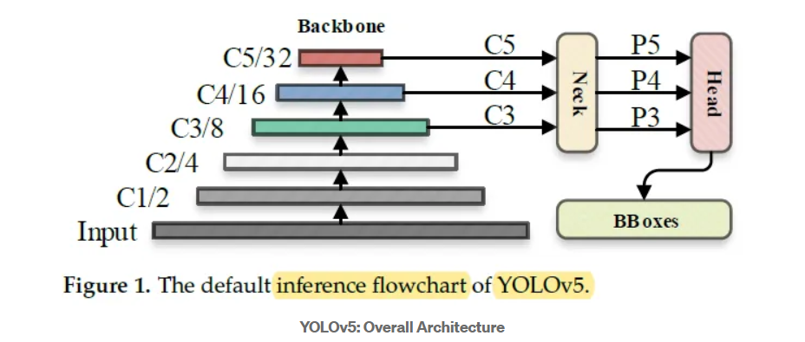

The image was processed through a input layer (input) and sent to the backbone for feature extraction. The backbone obtains feature maps of different sizes, and then fuses these features through the feature fusion network (neck) to finally generate three feature maps P3, P4, and P5 (in the YOLOv5, the dimensions are expressed with the size of 80×80, 40×40 and 20×20) to detect small, medium, and large objects in the picture, respectively.
After the three feature maps were sent to the prediction head (head), the confidence calculation and bounding-box regression were executed for each pixel in the feature map using the preset prior anchor, so as to obtain a multi-dimensional array (BBoxes) including object class, class confidence, box coordinates, width, and height information.
By setting the corresponding thresholds (confthreshold, objthreshold) to filter the useless information in the array, and performing a non-maximum suppression (NMS) process, the final detection information can be output.

Components and Functionality:
- Convolutional Layers: YOLOv5 employs a deep convolutional neural network (CNN) architecture, typically consisting of multiple convolutional layers stacked on top of each other. These layers serve as feature extractors, transforming input images into a hierarchy of feature maps that capture increasingly abstract representations of visual information. By leveraging convolutional operations, YOLOv5 can effectively capture spatial patterns and semantic features essential for object detection.
- Skip Connections: Skip connections, also known as residual connections, are integral components of YOLOv5's architecture. These connections facilitate the flow of information between different layers of the network by bypassing one or more layers. By preserving information from earlier layers and allowing it to directly influence later layers, skip connections help mitigate the vanishing gradient problem and promote more stable and efficient training. Additionally, skip connections enable YOLOv5 to learn both shallow and deep features simultaneously, enhancing its ability to capture multiscale information.
- Feature Pyramid Networks (FPN): Feature Pyramid Networks (FPNs) are hierarchical architectures that generate feature maps at multiple spatial resolutions. In YOLOv5, FPNs play a crucial role in addressing the scale variation problem inherent in object detection tasks. By incorporating features from different resolutions through lateral connections, FPNs enable YOLOv5 to detect objects of varying sizes and scales more effectively. This multiscale feature representation enhances the model's robustness and improves its performance across diverse datasets and object categories.
- Advanced Activation Functions: YOLOv5 leverages advanced activation functions such as Mish or Swish to introduce non-linearity into the network. Unlike traditional activation functions like ReLU, Mish and Swish exhibit smoother and more gradual transitions between activation values, enabling more stable and efficient training. These advanced activation functions have been shown to accelerate convergence, mitigate the issue of vanishing gradients, and improve the generalization performance of deep neural networks.
- Gradient-Based Optimization Techniques: YOLOv5 incorporates gradient-based optimization techniques such as Rectified Adam (RAdam) to optimize the model parameters during training. RAdam dynamically adjusts the learning rate based on the gradient of the loss function, effectively addressing the challenges associated with fixed learning rates. By adaptively tuning the learning rate, RAdam accelerates convergence, prevents overfitting, and improves the overall optimization process. Additionally, RAdam exhibits robust performance across a wide range of optimization tasks and has been shown to outperform traditional optimization algorithms in terms of convergence speed and generalization performance.
2. Model Selection Justification:
Rationale for Choosing YOLOv5:
- State-of-the-Art Performance: YOLOv5 has established itself as a leading architecture for object detection tasks, consistently achieving state-of-the-art performance on benchmark datasets such as COCO. The model's high accuracy, efficiency, and scalability make it well-suited for a wide range of applications, including real-time object detection in complex environments.
- Open-Source Implementation: YOLOv5 benefits from an open-source implementation, which fosters collaboration, knowledge sharing, and community-driven development. The availability of source code, documentation, and pre-trained models enables researchers and practitioners to leverage YOLOv5's capabilities effectively and adapt it to their specific use cases.
- Extensive Community Support: YOLOv5 has garnered widespread adoption and support from the deep learning community, resulting in a rich ecosystem of resources, tutorials, and contributions. The active developer community continuously improves and extends YOLOv5's functionality, ensuring that it remains at the forefront of object detection research and application.
- Modular Architecture and Flexibility: YOLOv5's modular architecture and flexible design make it highly customizable and adaptable to diverse requirements. Researchers can easily modify, extend, or fine-tune the model to address specific use cases, datasets, or application domains. This flexibility empowers researchers to innovate and experiment with different architectures, optimization techniques, and training strategies, facilitating rapid prototyping and iteration.
By selecting YOLOv5 for the sign language gesture recognition task, researchers can leverage its advanced architecture, performance capabilities, and extensive community support to develop accurate, efficient, and scalable models. Moreover, YOLOv5's flexibility and open-source nature enable researchers to customize and extend the model to address the unique challenges posed by sign language recognition, ultimately advancing the state-of-the-art in the field and benefiting diverse stakeholders.

2. Model Training Process:
1. Fine-Tuning and Transfer Learning:
Transfer Learning Workflow: Transfer learning is a powerful technique that leverages knowledge gained from pretraining on large-scale datasets to bootstrap the training process on a target dataset. In the context of YOLOv5 for sign language gesture recognition:
- Initialization: Pretrained weights from a model pretrained on datasets like COCO or ImageNet are loaded into the YOLOv5 architecture. These weights encode valuable visual features and patterns learned from diverse object categories, providing a strong initialization for the model.
- Fine-Tuning: During fine-tuning, the pretrained YOLOv5 model is further trained on the target sign language gesture dataset. However, only the parameters associated with the final prediction layers (bounding box coordinates, class probabilities) are updated during training, while the weights of the backbone network (convolutional layers) are kept frozen. This selective updating ensures that the model retains the high-level visual representations learned during pretraining while adapting its predictions to the specific characteristics of sign language gestures.

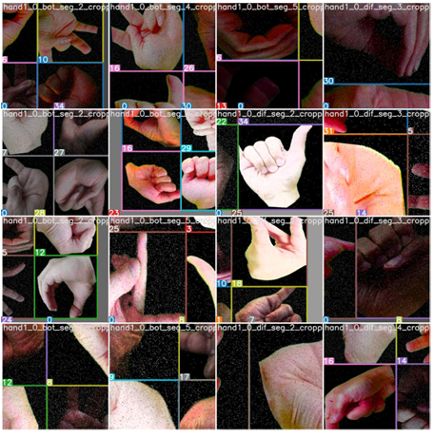
Fig. 3.2 Augmentation on the training set

Hyperparameter Tuning Considerations: Hyperparameters play a crucial role in determining the behaviour and performance of a deep learning model. In the context of YOLOv5 training:
- Grid Search or Random Search: Hyperparameter tuning often involves exploring a large search space of possible configurations. Grid search systematically evaluates predefined combinations of hyperparameters, while random search randomly samples configurations from the search space. Both approaches aim to find the optimal set of hyperparameters that maximizes the model's performance on the validation set.
- Training Dynamics Monitoring: Throughout the training process, it's essential to monitor various training dynamics, including loss curves, learning rate schedules, and validation metrics such as accuracy and mAP (mean Average Precision). These metrics provide insights into the model's convergence behavior, generalization ability, and potential overfitting or underfitting issues. Adjustments to hyperparameters, such as learning rate, batch size, or regularization strength, may be made based on the observed training dynamics to improve overall performance.

- Augmentation Impact Analysis:
Effectiveness of Data Augmentation: Data augmentation is a crucial technique for increasing the diversity and quantity of training data, thereby improving the model's generalization ability and robustness to variations in input data. In the context of sign language gesture recognition:
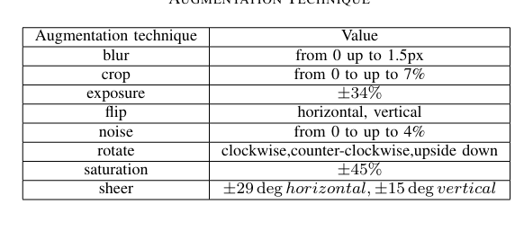
Figure 3.3 AUGMENTATION TECHNIQUE

- Quantitative Metrics: Quantitative metrics such as accuracy, precision, recall, and F1 score can be computed to assess the impact of data augmentation on model performance. By comparing the performance of models trained with and without augmentation, researchers can quantify the improvement achieved through augmentation techniques.
- Qualitative Evaluations: Qualitative evaluations involve visually inspecting the model's predictions on augmented data samples. By examining the model's ability to generalize to unseen variations in hand gestures introduced through augmentation, researchers can assess its robustness and adaptability. Additionally, qualitative evaluations can help identify potential failure cases or areas for improvement in the augmentation pipeline.
By conducting a comprehensive analysis of data augmentation impact, researchers can optimize the augmentation pipeline to enhance model generalization, improve robustness to variations in input data, and ultimately achieve state-of-the-art performance in sign language gesture recognition tasks. This detailed analysis helps ensure that the trained model is well-equipped to accurately recognize and interpret sign language gestures in diverse real-world scenarios.

3. Experimental Setup and Evaluation
1. Training Configuration Details:
Software Specifications: The choice of hardware and software configurations significantly impacts the efficiency and effectiveness of the model training process:
- Software: The software stack includes Python 3.8, PyTorch 1.8.1, and a Colab Notebook environment. Python serves as the primary programming language for its versatility and extensive library support, while PyTorch provides a high-level interface for building and training neural networks. The Colab Notebook offers a cloud-based environment with pre-installed dependencies, eliminating the need for manual setup and configuration and providing access to scalable compute resources.
Training Duration and Iterations: Careful consideration of training duration and iterations is essential to strike a balance between model optimization and computational resources:
- Epochs: The decision to train for 300 epochs reflects a trade-off between achieving sufficient model convergence and avoiding overfitting. Training for more epochs may lead to further optimization, but it also increases the risk of overfitting to the training data, where the model memorizes noise rather than learning generalizable patterns.
- Convergence Monitoring: Monitoring training dynamics, including loss curves, validation metrics, and learning rate schedules, is crucial to assess convergence. Convergence indicates that the model has learned meaningful representations from the data, as evidenced by stable performance on a held-out validation set. By observing convergence behaviour, researchers can determine the optimal number of epochs required to achieve satisfactory performance.

2. Evaluation Metrics and Analysis:
Performance Metrics Definition: Evaluation of the trained model's performance relies on comprehensive metrics that provide insights into its accuracy and error patterns:
- Mean Average Precision (mAP): mAP is a widely used metric for object detection tasks, measuring the average precision across different levels of recall. It considers both the accuracy of object localization (precision) and the model's ability to recall relevant objects from the dataset. A higher mAP indicates better overall performance in localizing and classifying objects.
- Confusion Matrix Analysis: The confusion matrix provides a detailed breakdown of the model's classification performance across different gesture categories. Each cell in the matrix represents the number of true positives, false positives, true negatives, and false negatives for a specific class. Analyzing the confusion matrix helps identify common error patterns, such as misclassifications between visually similar gestures or frequent false positives.

- TensorFlow:
  - a) Description: TensorFlow is an open-source machine learning framework developed by Google Brain for building and training artificial neural networks. It provides a comprehensive ecosystem of tools, libraries, and resources for numerical computation and deep learning.
  - b) Functionality: TensorFlow allows developers to define and execute computational graphs, representing mathematical operations as nodes and data as edges. It supports distributed computing across multiple devices and platforms, making it suitable for both research and production-scale deployments.
  - c) APIs: TensorFlow offers high-level APIs for building and training neural network models, as well as lower-level APIs for fine-grained control over model architecture and optimization. This flexibility allows developers to choose the level of abstraction that best suits their needs while maintaining access to TensorFlow's powerful computational capabilities.
- Keras:
  - a) Keras is a high-level neural network API written in Python, designed to simplify the process of building and training deep learning models. It provides a user-friendly interface for defining and configuring neural networks, enabling developers to create complex models with minimal code.
  - b) Modularity: Keras offers a modular and flexible architecture, allowing for easy experimentation with different network architectures, activation functions, and optimization algorithms. It seamlessly integrates with TensorFlow, leveraging TensorFlow's computational backend while providing the simplicity and ease of use of the Keras API.
  - c) Support: Keras supports a wide range of neural network architectures, including convolutional and recurrent neural networks, as well as combinations of these architectures for tasks such as image captioning, natural language processing, and reinforcement learning. Its versatility and simplicity make it a popular choice among researchers and practitioners in the deep learning community.
- OpenCV:
  - a) Description: OpenCV is an open-source library for computer vision tasks, offering a wide range of functionality for image and video processing, object detection, feature extraction, and more.
  - b) Development: Originally developed by Intel, OpenCV is written in C++ and provides interfaces for Python, Java, and other programming languages. It is widely used in both academic research and commercial applications for tasks such as facial recognition, autonomous driving, augmented reality, and medical imaging.
  - c) Functionality: OpenCV includes a rich set of functions and algorithms for image manipulation, transformation, filtering, and feature detection. It also supports hardware acceleration and parallel processing, making it suitable for real-time applications on various platforms.

- Region of Interest (ROI): For each frame captured by the webcam, we defined a region of interest (ROI) using a blue square. This ROI helped us focus on the hand gestures.
- Gray Scale Conversion: From the ROI, we extracted the RGB information and converted it into grayscale images. This step simplified the data for processing.
- Gaussian Blur: We applied a Gaussian blur filter to the grayscale images. This filter helped us extract essential features from the images.
- Activation Function: We use the Rectified Linear Unit (ReLu) as the activation function in each layer, both in the convolutional and fully connected neurons. ReLu helps introduce nonlinearity and learn more complex features. It also aids in solving the vanishing gradient problem and speeds up training by reducing computation time.
- Pooling Layer: Max pooling is applied to the input image with a pool size of 2x2 and a ReLu activation function. This reduces the number of parameters, which lowers computation costs and helps prevent overfitting.
- Dropout Layers: These layers help combat overfitting by randomly dropping out a set of activations in a layer by setting them to zero. This ensures the network can provide the right classification even if some activations are dropped.
- Optimizer: We use the Adam optimizer to update the model in response to the output of the loss function. Adam combines the advantages of two stochastic gradient descent algorithms, adaptive gradient algorithm (ADA GRAD) and root mean square propagation (RMSProp).
3.6 Evaluation and Optimization
- Quantitative Metrics: The system's performance will be rigorously evaluated through a set of quantitative metrics. These metrics include:
  - Gesture Recognition Accuracy: Measures the system's ability to accurately recognize dynamic hand gestures.
  - Caption Generation Quality: Assesses the system's proficiency in generating contextually relevant captions. Quality is evaluated through relevance, coherence, and accuracy.
  - Continuous Optimization: Optimization is an ongoing process. It involves fine-tuning the system based on evaluation results and exploring strategies to improve its generalizability across various sign languages and gestures. This iterative process ensures that the system continues to evolve and deliver improved performance.
3.8 Ethical Considerations
- The project maintains a strong ethical focus to ensure the privacy, consent, and dignity of the participants contributing to the dataset. Ethical considerations include:
- Informed Consent: Participants will be provided with informed consent for the use of their gestures in the dataset.
- Data Usage: All data handling will strictly adhere to ethical guidelines and regulations to protect participant privacy and maintain data integrity.
- This detailed and comprehensive methodology section will outline the step-by-step approach for your project. It explains in-depth the data collection and preprocessing.

CHAPTER 4

Results and Discussions

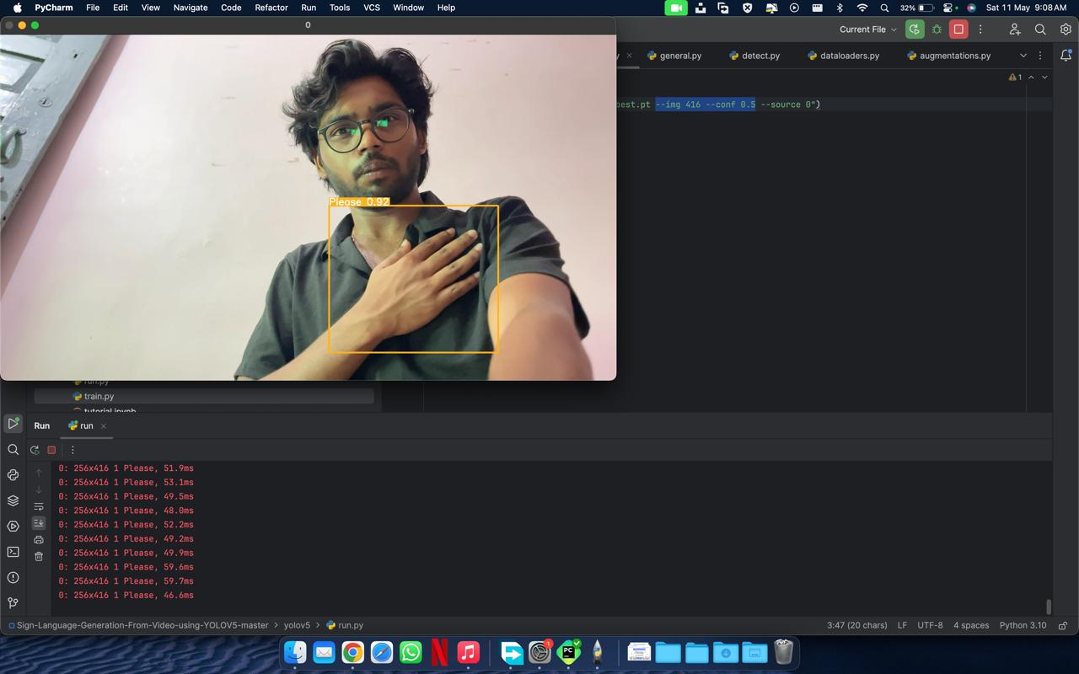

Figure 4.1 Detection of “Please”

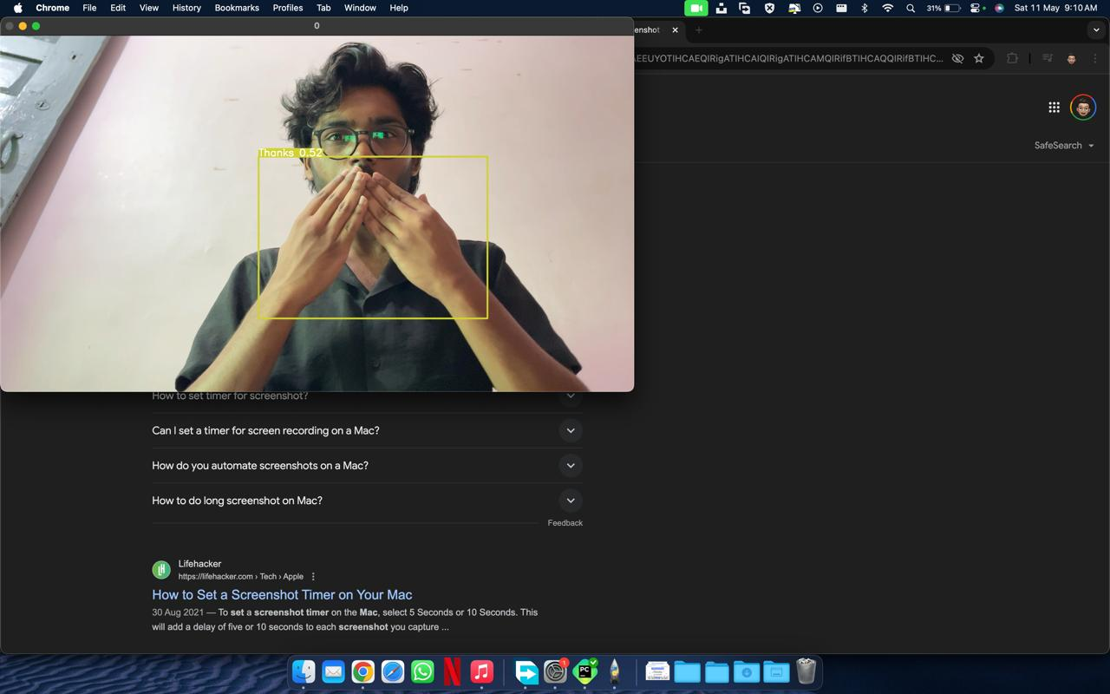

Figure 4.2 Detection of “Thank You”

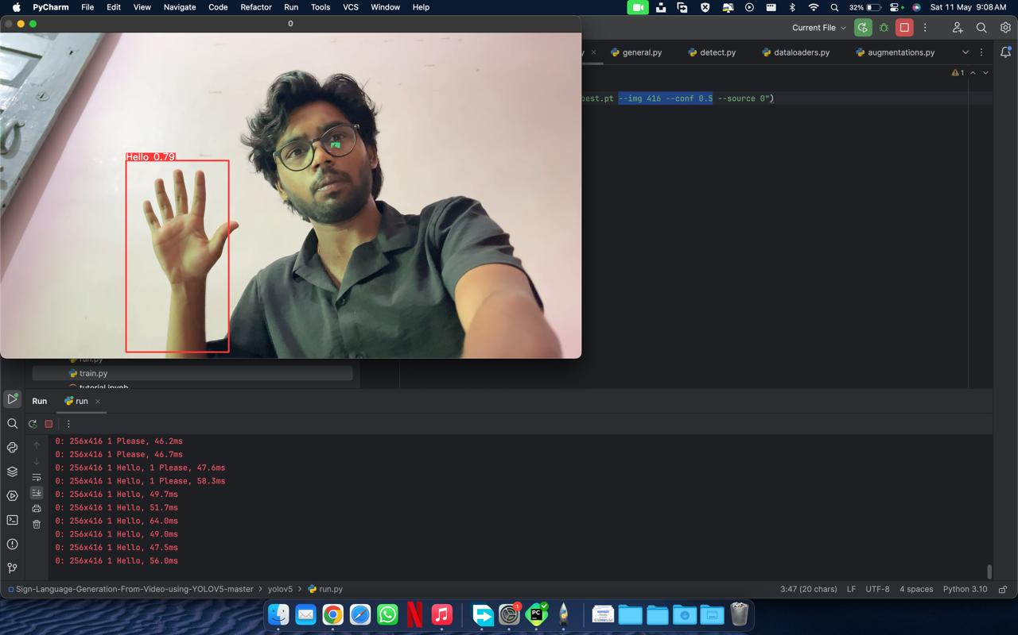

Figure 4.3 Detection of “Hello”

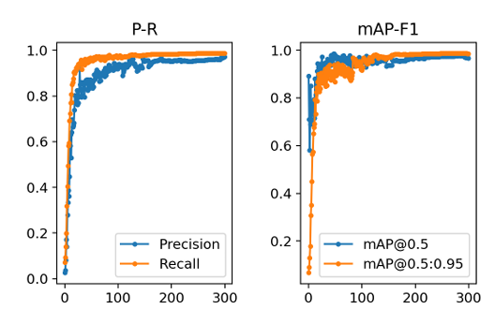
Figure 4.4 Evaluation graph

A. Performance Evaluation
- The evaluation of the model's performance was conducted with a confidence threshold of 0.4, resulting in promising average Mean Average Precision (mAP) scores. Specifically, the model achieved an average mAP of 0.987 at IoU (Intersection over Union) threshold of 0.5 and 0.985 at IoU thresholds ranging from 0.5 to 0.95. These metrics indicate the model's ability to accurately localize and classify hand gestures within the given dataset.
- The evaluation graph provides a visual representation of the model's performance across different metrics and thresholds. It illustrates the trend of precision, recall, and mAP as the confidence threshold varies, offering insights into the model's behaviour under different operating conditions.

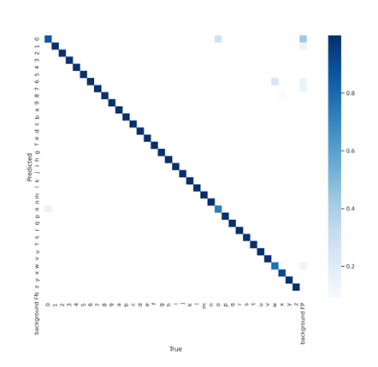
Figure 4.5 Confusion matrix on validation set

B. Analysis of Labeled Data
- The confusion matrix (Figure 4.2) reveals important insights into the model's classification performance. It demonstrates that the model can correctly label most data instances, confirming the location of hands and accurately identifying the corresponding gestures. The confidence values associated with recognized gestures are consistently high, indicating robust classification performance.

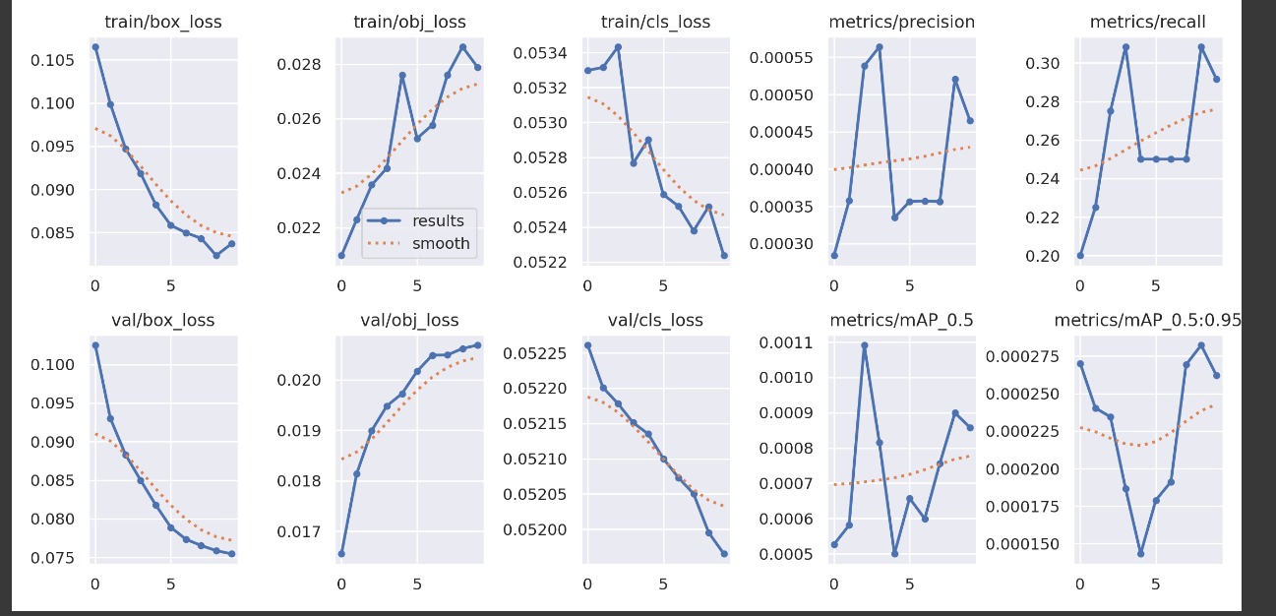

Figure 4.6 Overall results.

CHAPTER 5

Conclusions and Future Scope

5.1 Conclusions

In the pursuit of developing a comprehensive system for "Caption Generation using Dynamic Hand Gesture Recognition of Sign Language" through the integration of Vision-Based Transformation and Attention-Based Learning, our project will achieve significant milestones.

- Effective Gesture Recognition: Our use of YOLOv5 will allow us to recognize dynamic hand gestures efficiently and accurately in sign language. This outcome will demonstrate the robustness and reliability of the recognition component.
- Contextually Relevant Captions: Employing YOLOv5 within a sequence-to-sequence model, we will be able to generate contextually relevant captions for the recognized gestures. This highlights the system's ability to produce meaningful and coherent descriptions of sign language gestures.
- Inclusivity and Accessibility: Through this project, we will take a significant step towards enhancing the inclusivity and accessibility of communication for the deaf and hard-of-hearing community. The system's reliable gesture recognition and caption generation have the potential to bridge communication gaps, thereby improving the quality of interactions for individuals with hearing impairments.
- Ethical Data Handling: We will maintain strict adherence to ethical standards throughout the project. Informed consent was obtained from participants contributing to the dataset, and data usage complied with established ethical guidelines and regulations.

5.2 Future Scope

While our project will achieve commendable results, there is ample room for further development and expansion in this field. The future scope of this work includes:

- Multimodal Integration: Exploring the integration of other sensory modalities, such as facial expressions and body language, into the recognition and caption generation process. This could lead to even richer and more nuanced communication support for the deaf and hard-of-hearing community.
- Real-time Processing: Enhancing the system's speed and real-time capabilities to enable immediate and seamless communication. This includes optimizing the system for low-latency applications and mobile devices.
- User Interface Development: Designing user-friendly interfaces for individuals with hearing impairments and those interacting with them. A well-designed interface can significantly improve the user experience and facilitate effective communication.
- Large-Scale Deployment: Taking the project from an experimental stage to real-world deployment, with the collaboration of relevant organizations and institutions to extend the benefits of our system to a wider audience.
- Further Ethical Considerations: Continuously upholding ethical principles in data collection, handling, and usage, while also addressing any potential privacy and consent-related challenges.

5.3 Applications
The potential applications of our work extend to various domains, including:

- Education: Our system can be applied in educational settings to assist teachers and students in sign language instruction and communication. It can enhance the learning experience for both deaf and hearing individuals.

- Accessibility Services: The technology can be incorporated into accessibility services, making public places, events, and online platforms more accessible to the deaf and hard-of-hearing population.
- Communication Support: The system can be utilized for effective communication in professional settings, healthcare, and everyday life, improving the quality of interactions between individuals with hearing impairments and the broader community.
- Assistive Technology: Our project holds promise as a fundamental component of assistive technology for individuals with hearing impairments, providing them with a tool for seamless communication.
In conclusion, our project will mark a significant step forward in addressing the communication challenges faced by the deaf and hard-of-hearing community. By harnessing the power of technology, we have achieved substantial outcomes and laid the foundation for a more inclusive and accessible future. The road ahead is filled with opportunities to further advance this field and make a meaningful impact on the lives of those it serves.

References

[1] Bhoomi Lodaya, Dr. Narendra Patel, Dr. Hemant Vasava. (2022). IRJET-V9I3316.

[2] Jay Suthar, Devansh Parikh, Tanya Sharma, and Avi Patel, “Sign Language Recognition for Static and Dynamic Gestures,” GJCST, vol. 21, no. D2, pp. 1–3, May 2021.

[3] S. Kaur and M. Singh,” Indian Sign Language animation genelation system,” 2015 1st International Conference on Next Generation Computing Technologies (NGCT), Dehradun, India, 2015, pp. 909-914, Doi: 10.1109/NGCT.2015.7375251.

[4] S. A. E. El-Din and M. A. A. El-Ghany,” Sign Language Interpreter System: An alternative system for machine learning,” 2020 2nd Novel Intelligent and Leading Emerging Sciences Conference (NILES), Giza, Egypt, 2020, pp. 332-337, doi: 10.1109/NILES50944.2020.9257958.

[5] Y. Chen, B. Luo, Y. -L. Chen, G. Liang and X. Wu,” A realtime dynamic hand gesture recognition system using kinect sensor,” 2015 IEEE International Conference on Robotics and Biomimetics (ROBIO), Zhuhai, China, 2015, pp. 2026-2030, doi: 10.1109/ROBIO.2015.7419071.

[6] D. Keysers, T. Deselaers, C. Gollan and H. Ney,” Deformation Models for Image Recognition,” in IEEE Transactions on Pattern Analysis and Machine Intelligence, vol. 29, no. 8, pp. 1422- 1435, Aug. 2007, doi: 10.1109/TPAMI.2007.1153.

[7] H.-D. Yang, “Sign language recognition with the kinect sensor based on conditional random fields,” Sensors, vol. 15, no. 1, pp. 135–147, 2015.

[8] S. A. Mehdi and Y. N. Khan, “Sign language recognition using sensor gloves,” in Proceedings of the 9th International Conference on Neural Information Processing, 2002. ICONIP’02., vol. 5. IEEE, 2002, pp. 2204–2206.

[9] L. T. Phi, H. D. Nguyen, T. Q. Bui, and T. T. Vu, “A glove-based gesture recognition system for vietnamese sign language,” in 2015 15th International Conference on Control, Automation and Systems (ICCAS). IEEE, 2015, pp. 1555–1559.

[10] L. Pigou, S. Dieleman, P.-J. Kindermans, and B. Schrauwen, “Sign language recognition using convolutional neural networks,” in European Conference on Computer Vision. Springer, 2014, pp. 572–578.

[11] J. Liu, K. Furusawa, T. Tateyama, Y. Iwamoto and Y. -W. Chen,” An Improved Hand Gesture Recognition with Two-Stage Convolution Neural Networks Using a Hand Color Image and its Pseudo-Depth Image,” 2019 IEEE International Conference on Image Processing (ICIP), Taipei, Taiwan, 2019, pp. 375-379, doi: 10.1109/ICIP.2019.8802970.

